Published 29th. January 2021 by Jørn Watvedt for UpWork project.

Phase 1 Rev 2 update 27 April ready to complete and close Phase 1

Phase 1 Rev 1 Update 24 Feb finalized BOM and budget and ready to hire.

Phase 0 Rev 0 Update 24 Feb 2021: Updated with information from Vu document, and prepared as final for Phase 0

31 Jan Rev 2: Added details for Raspberry PI

Joystick piloting for outboard motorboats was a popular topic 10 – 15 years ago, when the major manufacturers started developing and offering these systems. However, the excitement has much died off because of complexity, limited user benefit, high price, and the inherent limitations of big money big industry proprietary systems.

However, since then, there has been a revolution in vehicle piloting driven mostly by open-source contributions to the RC and especially RC / autopiloted drones. Now time is right for revisiting boat joystick piloting and all the current smart navigation opportunities that has become available thru ArduPilot and the associated hardware. Not only that, but quality, reliability and safety of these current technologies are certainly competitive, compared to current industrial solutions (which are 10 years old …..)

Outboard motorboats with 2 motors that are controlled independently in respect to throttle, shift, steering, and trim have vast opportunities for total boat control. Much like that recent controllers with gyro/compass/GPS/PID instrumentation made drone piloting possible, these same technologies are now ready to unleash similar transformation for outboard motorboats with 2 (or more) engines.

Now time is right to start, and start small, with a common RC boat, equipped with 2 outboard motors with independent controllers. Make it work with regular dual joystick RC controller, one joystick for each motor and a sea-trial will be convincing; Perform a sideways walk by vectoring the engines such that the resultant vector pushes the boat directly sideways. And so on!

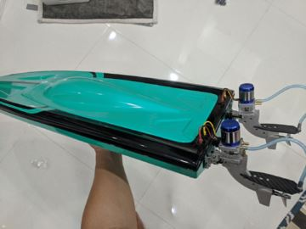

The objective of this project is to start small, start simple with current RC boat equipment and iterate and iterate and iterate. Maybe one day we feel confident to move the controller onto a full-size boat.

**Phase 1 conclusions**

as pr 27. April 2021

**Diagram conclusion:**

Replace “servo motor for reverse bucket” with “servo motor for steering +/- 45 dgr.”

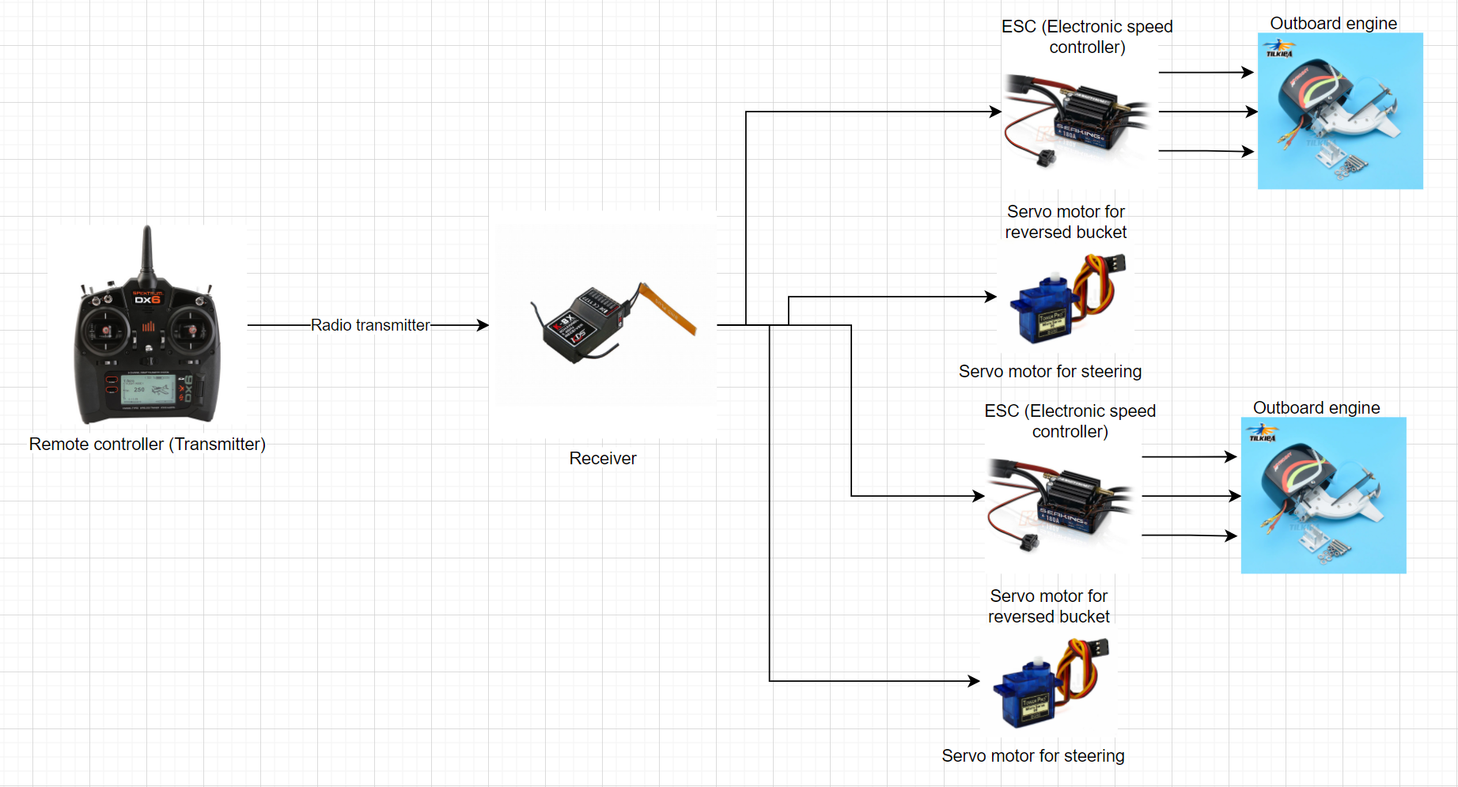

**Finalized boat**

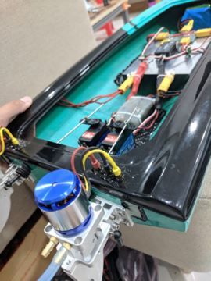

Our plan is to replace the original The KV3000 motors with motor with KV1100.

Reason is that the KV3000 motor is not possible to control precisely at low RPM = when starting.

No other changes are expected at this point.

Vu: Please add comments as you feel.

In my point of view, the most difficult is attaching motors to the back and choosing transom posistion.

For future works, the experiences are:

. A “profile” of back side must be extract to the paper by redrawing. Put the motor to this paper for redraw the motor’s holder profile. After that, paste this paper back to the boat and start drilling holes.

. Drilling needs from to be done in from smallest drill bit to largest one (Do not use the largest at the first time)

. Water proof is the need

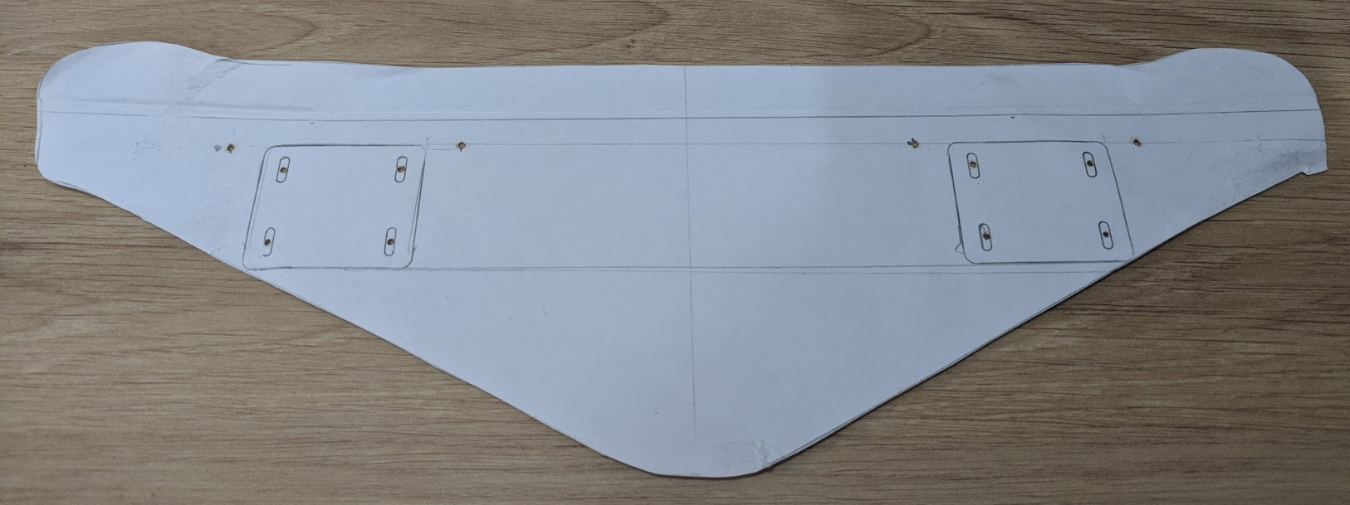

Example of boat’s backside profile

**BOM Bill of Materials:**

Vu: Please update BOM to actual BOM with approx. pricing

|  |  | Quantity | Estimated Cost | Total | Remarks |
| --- | --- | --- | --- | --- | --- |
| **Engine** |  |  |  |  |  |
|  | Outboard | 2 | $100 | $200 | <https://vi.aliexpress.com/item/32878931653.html> |
| **Chassis** |  |  |  |  |  |
|  | Single hull | 1 | $40 | $40 | Vietnamese local store |
| **Controller** | Transmitter FRSky QX7 | 1 | $130 | $130 |  |
| **Receiver** | Receiver X8R | 1 | $34 | $34 | Kết quả hình ảnh cho recevier x8r  1Km range in airbone, expected 700m in water  It has SBUS channel which is compatable to Ardupilot in the future |
| **ESC** | Reversible ESC | 2 | $41 | $82 | <https://vi.aliexpress.com/item/4000379124148.html?spm=a2g0o.productlist.0.0.5e185b14G3B6kG&algo_pvid=4be96b4c-7aed-435c-9d64-196452ffc3b9&algo_expid=4be96b4c-7aed-435c-9d64-196452ffc3b9-33&btsid=0bb0623c16195695143053870ef003&ws_ab_test=searchweb0_0,searchweb201602_,searchweb201603_> |
| **Servo** |  |  |  |  |  |
|  | JX DC5821LV 20 Kg | 4  2 | $21 | $84  $42 | <https://www.ebay.com/itm/JX-Waterproof-Metal-Gear-JX-DC5821LV-20KG-Large-Torque-Digital-Coreless-Servo-/174125079363>  Image 1 - JX-Waterproof-Metal-Gear-JX-DC5821LV-20KG-Large-Torque-Digital-Coreless-Servo  Water proof |
| **Batteries** |  | 2 | $50 | $100 |  |
| **Accessories** | Glue, water cooling pipe, water pipe separator, servo link, screw… | 1 | $50 | $50 |  |

Estimated cost is $650,-

**Process timeline Phase 1**

Parts arrived at end of March

( Due to Covid 19 parts availability and delivery has been very difficult)

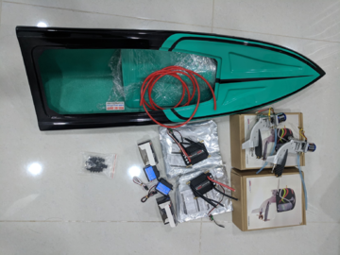

Boat was ready for sea-trial 15th. April



Phase 1 is being completed, including updating of documentation, by the end of April.

Effectively, the Phase 1 was completed during the month of April 2021.

**Work hours:**

Vu: Please update with approximate hrs.

Work budget for Phase 1 as per Vu estimate: $7.29 for construction, setting up and testing

About the budget hours, I will spend 20 hours per week, so we have 3 weeks, it would be 60 hours in total.

**Phase 1: RC boat with 2 outboard engines controlled by individual joysticks.**

Vu: Please write a short summary about your sea-trial experience with controlling the boat fully manually.

IMPORTANT: Scope of Phase 1 also includes BOM and budget material and work for Phase 2.

Before the sea-trails:

. Make sure motors and servos work properly

. Batteries, power distribution, receivers and other non-water resists must be placed as high as possible (the should be light because tall COG of the the boat is not good)

. Water proof the motor connectors (with hot glue)

. Enough battery

. Do not forget the controllers (this happens to everyone sometimes!!!)

During the sea-trail

. Do not close the boat with the cap so we can observe serious water leak at very first water surface contact

. Slowly put the boat into water surface, slowly let it go and make sure it not to flip of sink

. Observe the water leak if it happens

. If the leakage is serious, find the source by slowly dip the boat into water and observe.

. Water level should be low enough with respect to the edge:

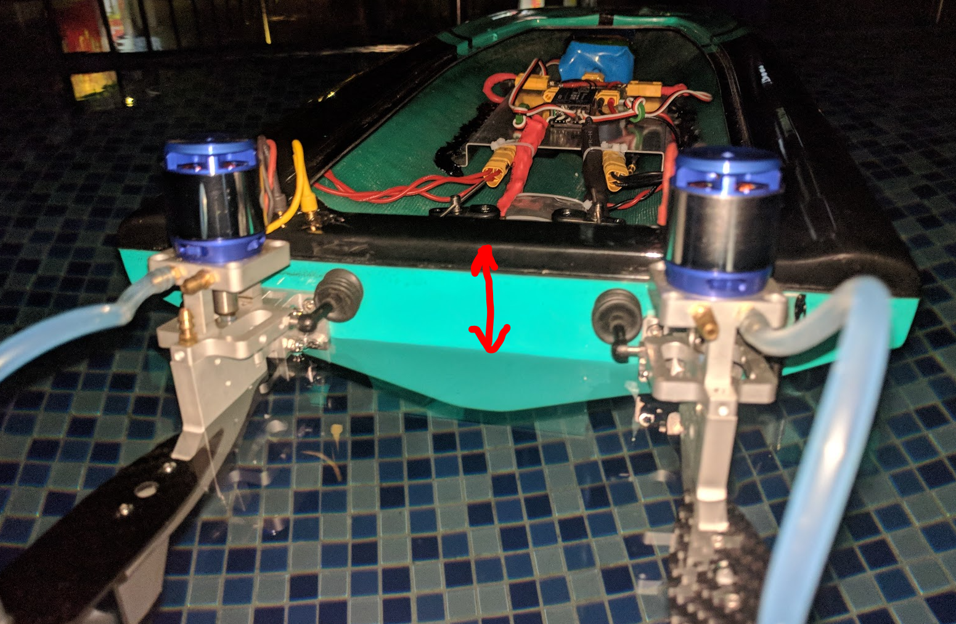

. Close the hull with its cap by non-sicky tape

. Input low sticks forward and observe any odds (if there is), increase the stick until full speed, lower down the stick (do not release quickly). Repeat the same for reward direction

. Confidently steer the boat with servos and try 2 methods of steering: differentialy and skid

**Phase 2: Add simple controller for software vectoring of motors.**

Operational mode settings:

Updated by Joern 27th. April 2021 Phase 1 Rev 2:

1. Dual joystick “Skid-steering” type of control, where motors are NOT turned. Purpose is to test algorithms for 4-wheeled skid steering ( bobcat steering or tank-turn). Joysticks work as steering sticks, the Y-axsis is not used.
2. Dual joystick = Forward/backward and steering individually for the motors. Purpose is to always be able to go back and test specific maneuvers manually.
3. Single right joystick = Strict synchronized operation of motors in tandem. Purpose is to experience this typical ( low cost) boat control.
4. Single vectored joystick = Programmatically calculate for each motor RPM and steering angle so that boat moves in the direction of the joystick. Maybe by having list of pre-calculated values for a lookup function.

The above 4 different operational modes should be selectable by switches at the controller / transmitter. ( Allowing experimenting with various strategies during sea-trial)

Maybe ideas about other operational modes?

Objective is to be able to play with different settings and understand the dynamics of having two articulated motors.

Each operational mode probably requires a table of SETTINGS that may be updated to experiment with and better understand boat behavior.

NO CHANGES MADE BEYOND PHASE 2.

**Phase 3: Define system hardware and software.**

Now we are ready to define with ArduPilot and what hardware to use for compass, gyro and GPS.

Issues: Cost, availability, competence required, and so on.

Ardupilot has several steering options:

<https://ardupilot.org/rover/docs/rover-motor-and-servo-connections.html>

Also different versions of vectored thrust:

<https://ardupilot.org/rover/docs/rover-vectored-thrust.html#rover-vectored-thrust>

Joystick piloting allow straight sideways movement of boat, as an illustration of what is possible, by vectoring.

Sketch explaining motor vectoring for sideways movement: Motor A and Motor B have angular direction and force, which is revectored into Ax/Ay and Bx/By respectively.

The resultant force R = Ax+Bx is pushing the boat sideways IF resultant moment from all forces around “COJ” ( Center of Joystickoperation = think of CoG Center of Gravity but for water friction forces) = 0 zero. Controller must be able to run this calculations.

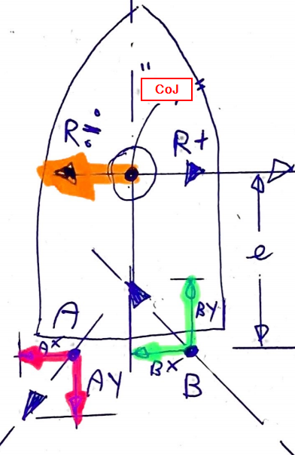

Ardupilot has several steering options:

<https://ardupilot.org/rover/docs/rover-motor-and-servo-connections.html>

Also different versions of vectored thrust:

<https://ardupilot.org/rover/docs/rover-vectored-thrust.html#rover-vectored-thrust>

**Phase 4:**

Update Boaty McBoatSurFace with new System for sea trials.

Identify issues and strategies to solve these issues.

**Phase 5:**

First full RC system

**Phase 6:**

RC System Ver 1.0

**Phase 7:**

Define Real Boat System

Real Boats us NMEA 2000 for data transfer, and there is an Open Source solution for communication:

<http://signalk.org/>

We are going to use Raspberry PI:

<https://seabits.com/nmea-2000-powered-raspberry-pi/>

**Phase 8:** Build hardware for Real Boat System.

**Phase 9:**

Develop and install software on the Real Boat System. Sea Trials

**Phase10:**

Real Boat System Ver 1.0